**Split Session Rules**

T Bond S lit Session Rules

# * Traditional Overnight Session: London New York Am Session: 8:00 am to Noon New York Pm Session: Noon to 3:00 pm

**Trending Days can see the complete trading day be one­**

**sided in both An1** & **Pm Sessions.**

**s,v ing and the other be quiet or consolidate.**

**Or it can see one Session produce a**

**Arn** & **Prn Sessions.**

**Days can see opposing directions in the**

**Consolidation**

Commodities have a unique time of day as well

These lessons are primarily focused on the new york sessions London can also be traded in the bond market

The AM session will have the higher/low of the new york session because it has the largets volume The PM session will likely be a continuation or reversal or a consolidation

Mainly focus on the AM session, that will have the best moves The AM and PM sessions together create the daily range

The day can also start with the PM session if theres late news



For the AM session we can look what London did and that will give us an idea where the overnight stops are liquidity void FVGs, any measure of PD arrays

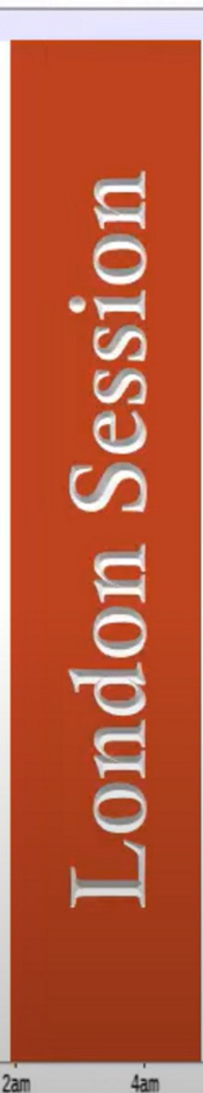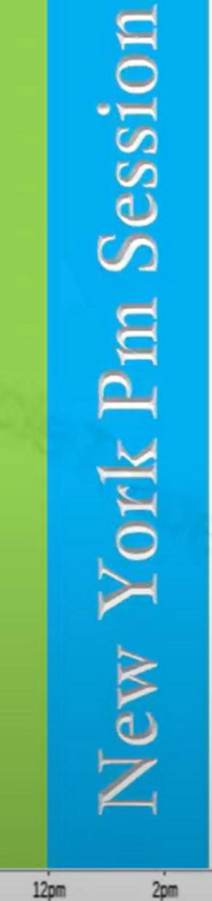

ZBU17 T-Bond -15Minute Candlestick Chart

□

**12Ml**

**6.1n**

**Sall**

**10am**

**1)11**

**9pm**

**llpm**

Sometimes the AM sessions can close as early as 11am, the London close time period. New york lunch, 11am to 1pm

If you have a runner in AM then you can generally see a follow trough in the PM session. If weve already seen a large part of the ADR in the AM session then the PM session will be rather abbreviated. So we can use this in the sense that if the AM session has already traded a big portion of the ADR and before lunch it goes flat then we dont have to come back for the PM session

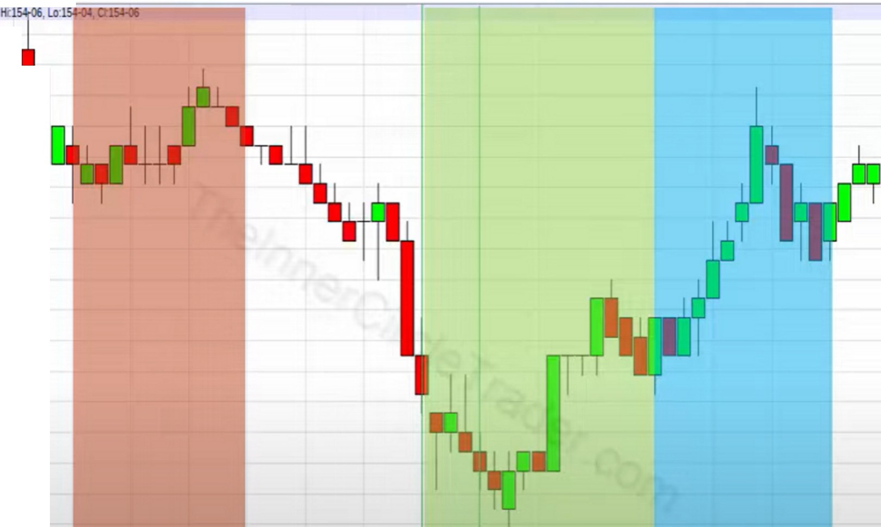

ZBU17 • T-Bond • 15 Minute Candlestick Chart

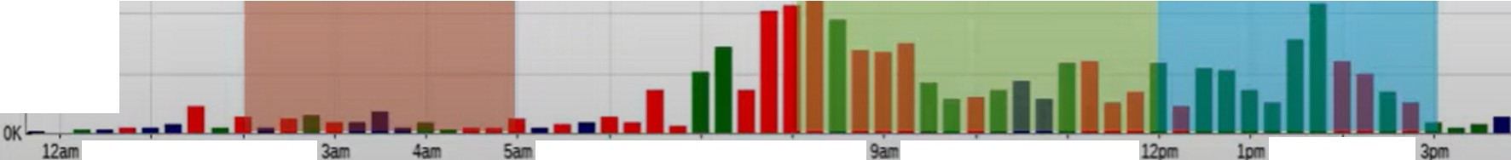

□Op:154-05,

154-14

**'It**

- LS4-13

I

- LS4-ll

LS4-10

-154--08

--

-154-05

-154-03

J154-02

-154-00

- 153-27

153-26

153-24

-153-22

-153-21

-153-19

(c)Batchalt.ccm 15K I Vat JJ9

**!OK**

---=-=-=a-=153·18

SK

**1all**

**2-**

**6a**

7•

Ila

**10.. u.**

**2pl**

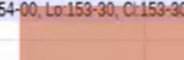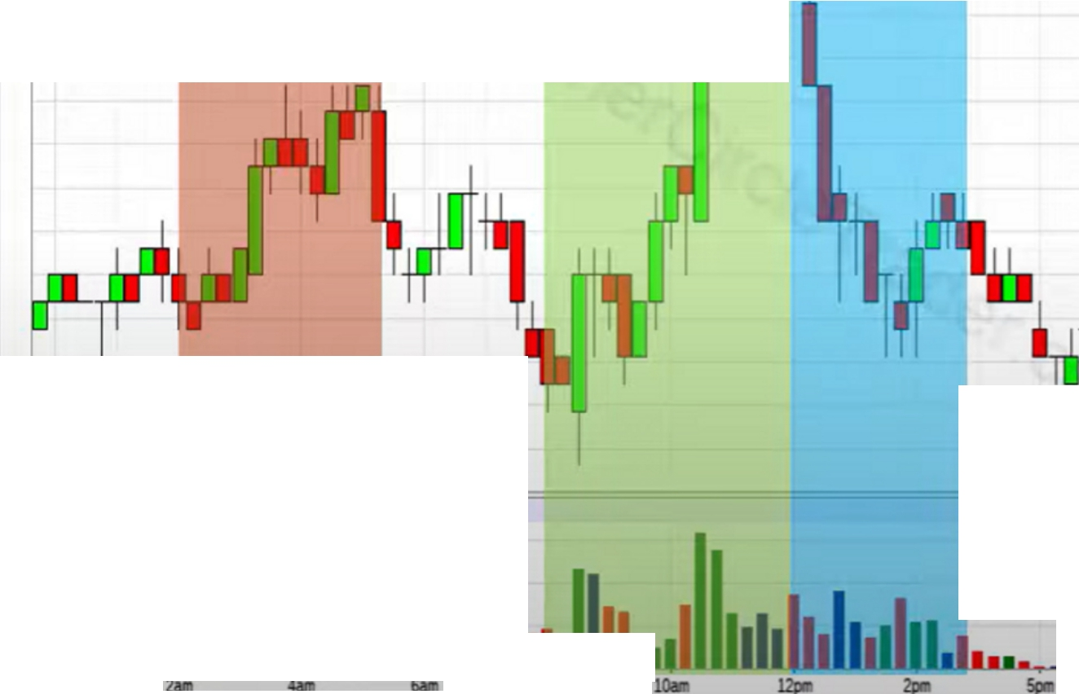

I Op·l54-00, tu

(C) Batchalt.ccc,

20K ■Vat225

15K

lOK

SK

**OKl.:,---'. .,...._,...._....._..ll.J.IQl !M!**

l2Mo

LS4-22

15Hl

154-19

LS4-18 LS4-16 154-14 LS4-13 154·11

154·10

154--08

154--06

154-(15

154-03

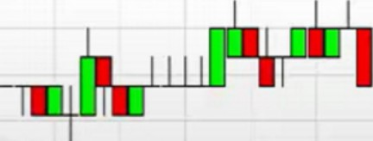!s«>:2

154-00

**11m**

153-29

153·27

153-26 r==-===============;153-24

**7pa**

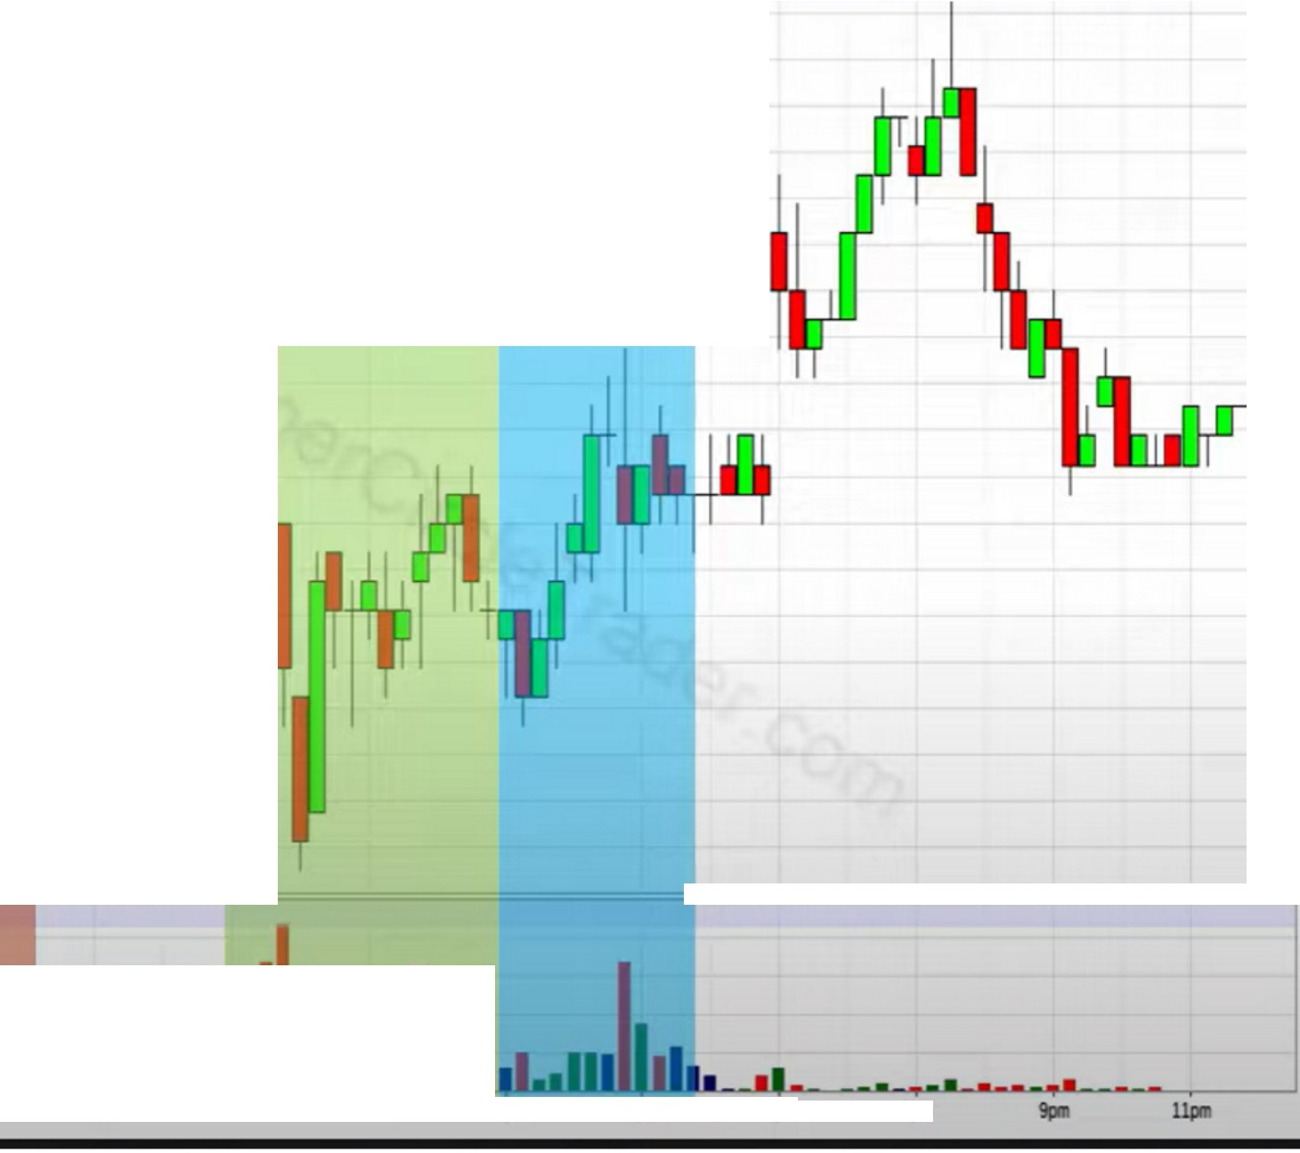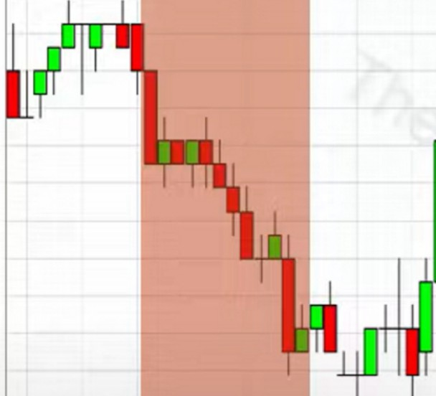

rao..i"54Ti"iiIBi M;;;;,;m;;,- ------------======, 7l54-27

154-26

1154-24

154-22

154-21

154-19

-

154-18

154-16

154-14

154-13

15Hl

154-10

154-0S

154--06

**(c) Baichan.can**

**25K** ■**Vol:99**

**201(**

154-03

154-02

154-00

153.30

153-29

11==================;153·27

**15K**

**!OK SK OK**

**12am**

**2all**

**4a**

**6aa**

**a..**

**10.**

**,J....**

**121a**

**2ia**

**Spa**

ia

When theres a large opening range we want to look for retracement ideas

The market times overlaps with forex, you can see at new york open time in forex the bond market also gives a reaction

When you study this you can see the impact the bond market has on the other markets

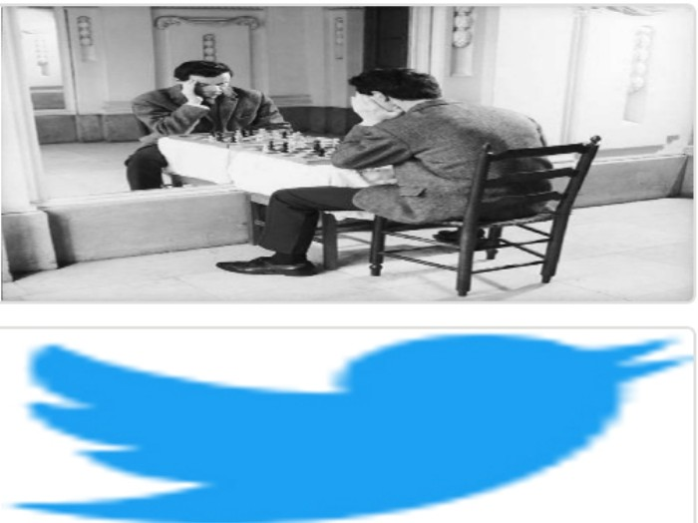Arjo I Twitter, lnstagram I Linktree

Linktree. Make your link do more.

, https://t.co/HhmmTN1fUI

JavaScript is not available.

***"'JI*** https://twitter.com/arjoio